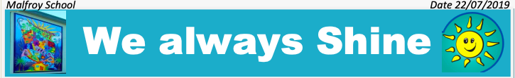
Room 11 Newsletter Term 3 2019

Whakatauki:
"Mō tātou te taiao ko te atawhai, mō tātou te taiao ko te oranga"
"It is for us to care for and look after the environment to ensure its wellbeing, in doing so we ensure our own wellbeing and that of our future generations"
This term we continue to focus on our environment, we investigate biosecurity in New Zealand and how we can care for our environment (sustainability). Our literacy (reading and writing) and art will align to biosecurity and sustainability. In maths, we continue to hone our multiplication and division skills, we learn more about fractions, percentages and measurement.
Our PE focus is on learning and applying winter sports skills in basketball, soccer, netball, rugby and team events.

W

It was wonderful meeting you at your child’s achievement discussions.
Do continue to have conversations with your child about what they are learning and any new challenges or goals that they are striving towards.
Promote the importance of having a growth mindset and being resilient in everything they do.

HOME LEARNING- Remember to refer to your child’s report “How I can help at home”
Reading books and a reading log come home every Monday in their ‘Book bags’.
Ensure your child reads for 15-30 minutes a day and fills in their reading log.
Extra learning can be done using Studyladder, IXL, Reading Eggs and Sumdog.
Remember to read and comment on your child’s blog regularly. We showcase our learning outcomes here. Whaea Jo's Class Blog. Copies of this newsletter are also found in the Parent Tab in our class blog along with information about the websites we use often.
Malfroy School is a Cornerstone Values School
The programme focuses on the 8 Values of Respect, Duty, Responsibility, Consideration, Kindness, Honesty, Truthfulness, Obedience and Compassion.
The focus for Term 3 is Honesty and Truthfulness.

Remember to read our School App every Thursday for information and updates.
Extra newsletters about specific events during the term will be included in the School App.

Regards

Whaea Jo
joannejenkins@malfroy.school.nz

