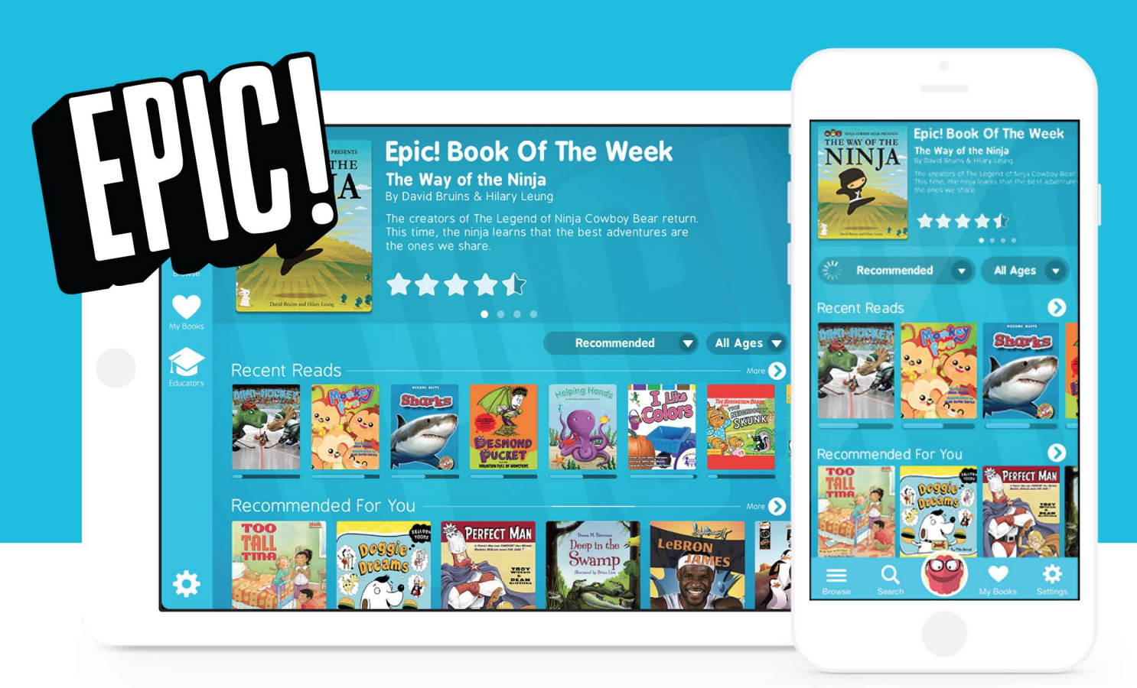
Your child knows how to access this site. Everytime they do it is recorded.
Promote reading at every opportunity.

